AUDIOBOOK PLANS

PUBLISHING & MARKETING

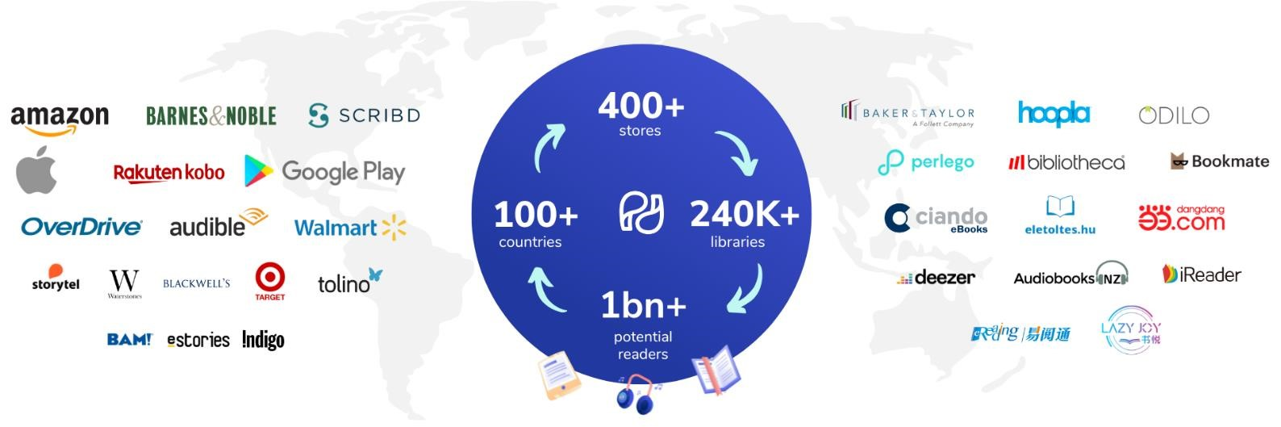

# Standard Narrator Plan – $499

* Narrator (20 Published Audiobooks)
* Studio Recording (Dolby Sound Quality)
* ACX Account Creation
* Publishing on Audible, Spotify GoogleBooks, AppleBooks and Barnes & Noble
* Audiobook Promotion

# Premium Narrator Plan – $999

* Narrator (100 Published Audiobooks)
* Studio Recording (Dolby Sound Quality + 4K Sound)
* ACX Account Creation
* Publishing on Audible, Spotify GoogleBooks, AppleBooks and Barnes & Noble
* Audiobook Promotion

# Best-Seller Narrator Plan –$1499

* Narrator (20 Best-Seller Audiobooks)
* Studio Recording (Dolby Sound Quality + 4K Sound)
* ACX Account Creation
* Publishing on Audible, Spotify GoogleBooks, AppleBooks and Barnes & Noble
* Audiobook Promotion

*These Offers and Packages are a limited time offer and are available during the current month and will not be continued on the exact same pricing the following month. All Packages are subject to revisions in price at the end of every month. Once the desired plan has been purchased on the particular month’s tariff, the customer is not eligible for any extra costs.*